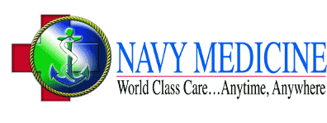

**Benefits:**

• 1 and 2 year scholarships available

• Enlisted as a First Class Petty Officer (E6) with pay

• Advancement Opportunities

• Housing Allowance

• Earn 2.5 vacation days per month

• Access to all Military Exchanges and Commissaries around the world

• Full Medical Benefits to you as well as your spouse and children

The Health Services Collegiate Program (HSCP) is a scholarship program designed to provide financial incentives for students in designated health care professions to complete degree/certification requirements and obtain a commission in the Medical Service Corps (MSC).  
  
Read more at: https://www.navycs.com/officer/hscp.html

**Eligibility Requirements:**

• Citizenship - Must be a U.S. Citizen

• Age - Complete your degree by age 42

• Health - Must meet the Navy’s physical requirements

• Education - Must be enrolled in, or accepted for transfer into a college, university or school of study for a Master’s Degree in Physician Assistant Studies accredited by the ARC-PA. Must have a cumulative GPA of 3.0 or above to apply. Must complete studies/training as full time students attending all normal school sessions and must maintain a GPA of above 3.0 after selection.

• Degree requirements must be fulfilled within 24 months

**How to Apply:**

• To apply for the Health Services Collegiate Program, request additional information, or if you have questions, contact:

**NC1 Ken Bozeman**

**Navy Recruiting District Houston**

**9990 Richmond Ave Ste. 200 South**

**Houston, TX 77042**

**281-846-8302**

**kenneth.bozeman@navy.mil**

**NAVY HEALTH SERVICES COLLEGIATE PROGRAM (HSCP)  
PHYSICIAN ASSISTANT SCHOOL**

**Service Obligation:**

• Medical Service Corps (MSC) minimum obligation is three years.