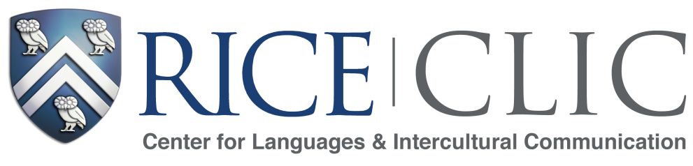

Language Courses for 2019-2020

The Center for Languages & Intercultural communication offers courses in 10 languages:

Arabic Japanese
Chinese Korean
French Portuguese
German Russian
Italian Spanish

Before studying a language with CLIC, you must take the Language Placement Test for that language, even if you have no prior knowledge.

- Students may access the placement tests through our website at clic.rice.edu/placement-test.
- The tests are open from May 29 – June 24 for fall 2019 enrollment.
- Tests will be graded during July and students will receive placement results by August 1.
- Tests will open again August 16th – August 28th for fall 2019 enrollment.
- Students can expect to wait 1-2 days from the time they finish the test to receive the placement results and another 1-2 days after that for the placement to be recorded with the Registrar’s Office to allow students to register via Esther.
- Tests will take approximately 30 minutes to complete. If you have no background in the language, you need only answer a few questions.
- The placement test is not required for 300 and 400 level courses in French and German nor for Spanish courses with the SPPO course code.
- Students who have taken a language course with CLIC and plan to continue studying the same language do not need to retake the placement test.

Rice in Country Summer Study Abroad

- In summer 2019, CLIC sent students to China, France, Italy, Japan, Korea, and Spain for intensive language courses on faculty-led study abroad programs.
- The Rice in Country programs, designed and led by Rice faculty for Rice students, feature homestays, community engagement, language partners, and cultural excursions.
- Students earn six Rice credits in six week and may be eligible for scholarships to help defray the cost of participation in these programs.
- CLIC will announce programs for summer of 2020 in fall 2019.

Certificate of Language and Intercultural Communication

- The Certificate of Language and Intercultural Communication gives Rice undergraduates a method to demonstrate significant second-language abilities to potential employers and others.
- The Certificate will appear on the student’s official Rice transcript.
- Students interested in pursuing the Certificate should review the requirements on our website at clic.rice.edu/certificate.

